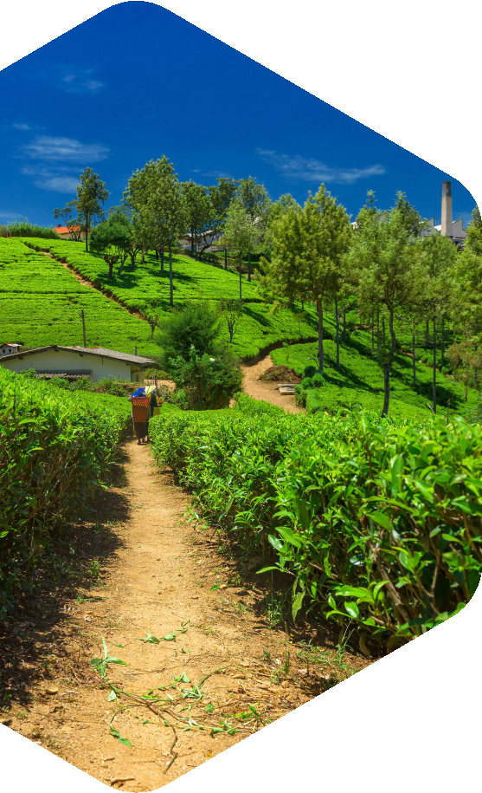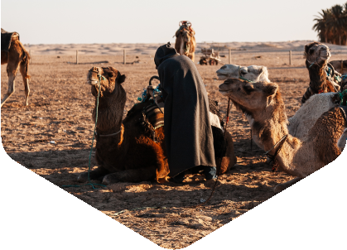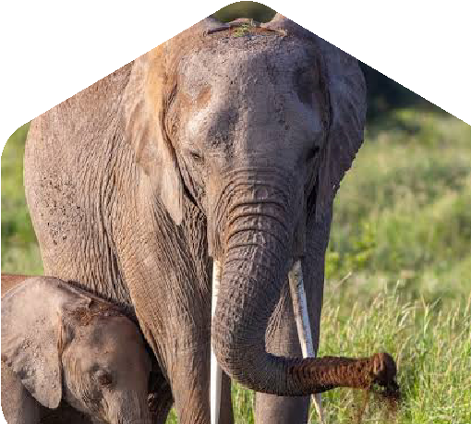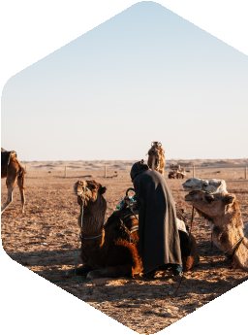

**Travels.co**

Revealing Eastern India's

Natural Richness

**Our Pledge:**

Real Testimonials

**Travel .co, a**

**credible partner**

**for an unusual**

**travel experience**

**in East!**

Kunal Sharma

**Promoting local conservation**

**projects and sustainable tourism.**

•

**Mangrove Trails**

•

**Tea Estate Tours**

•

**Monastery Visits**

•

**Wildlife Adventures**

**Approach With sustainable**

**travel at the core, EastEscape**

**thrives on protecting the**

**captivating terrains of**

**East India.**

**Offerings**

**ABC Exotic Travels guides explorers**

**through Eastern India's hidden**

**landscapes, unfolding the wonders**

**of this region.**

**About Us**

**Contact Us**

**xxxx 9xxxx**

**+91 9**

**info@companyname.com**

**I-1A, Sector 25A, Noida,**

**U.P. 201301, India**